How to join an HPCI webinar with GoToWebinar

Overview

You can join a webinar from your pc, laptop, tablet or smart phone! A webinar is a type of online talk where you can hear and sometimes see the presenter and the slides for their talk. You can ask questions or make comments in a chat box. You can take part from the comfort of your home, work place or wherever you have an internet connection.

How to Register

In the email invitation sent to you, there will be a link to register for the Webinar (1 in below figure.) Please do register when the invitation is received as there may be a limit to the number of attendees that can access the webinar and you do not want to miss out. Early registration will ensure that the organisers of the webinar can adequately plan for the number of attendees expected.

In the invitation mail, you will also see a link to view the system requirement of the webinar (2 in below figure) which explains what systems are required on your pc/device to support the webinar. There is no reason to explore this unless you are having issues accessing the webinar.

If you’re going to access the webinar from your smartphone or tablet, you might want to download the GoTo app (which is available from the App Store or from Google Play for Android users) in advance of the event.

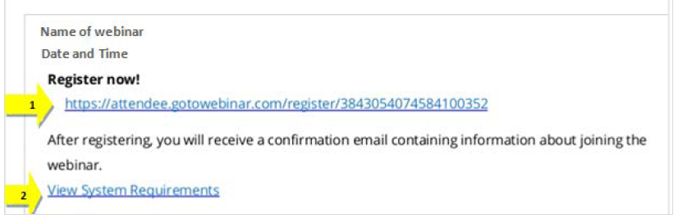

Next, you will be taken to the registration page of GoToWebinar. Enter your name (3 in below figure) and email address (4 in below figure) then click on ‘Register’ (5 in below figure.) As stated in the registration page, when you click on ‘Register’ your details will be sent to the webinar organiser.

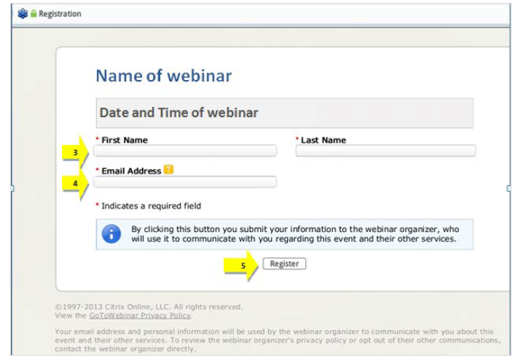

There may also be a few pre-event questions which will help the organisers focus the content of the webinar to the needs of those attending.

Following registration, you will be sent an email with an individual link to join the webinar at the time the webinar is scheduled for. Do not share this link with anyone else as it will only let one person join using it.

If you do not receive a confirmation mail with further instructions within a few minutes of registering, please contact your webinar organiser (Kate Hudson at kate@hertsparentcarers.org.uk)

This email will give you the option of adding the webinar to your outlook/email calendar if you wish (6 in below figure.) This mail will also give you details of the webinar organiser and how to contact them with any queries (7 in below figure.)
Just prior to the required time of the webinar click on the link to join the webinar (8 in below figure.)

If this is the first time you have joined a GoToWebinar, please give yourself a little more time to join, as you may need to download the necessary software to support this webinar and future webinars.

This page also gives information on audio options during the webinar (9 in below figure) using your computer/devices audio is the easiest option if you have a good connection to the internet. You only really need to phone in if your internet bandwidth is not too good, however if you dial in with a phone you can still follow the visual aspects of the webinar on your PC/laptop.

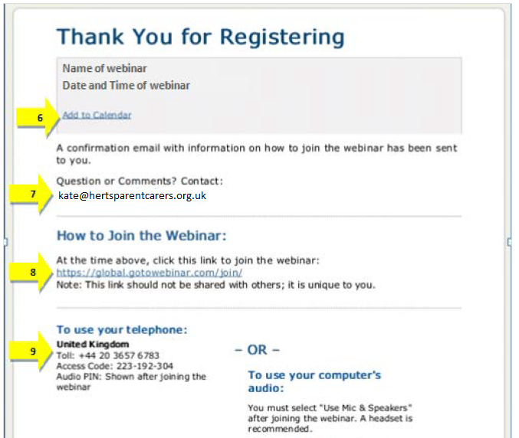

Joining the webinar

When you choose to join the webinar for the first time you will be prompted to download the necessary software if you haven’t done so already, please see the below figure (please note however that dependent upon your computer/device this may show in a slightly different format.) Once this has been completed just click on the option to join the webinar at the specified time and date (10 in below figure.)

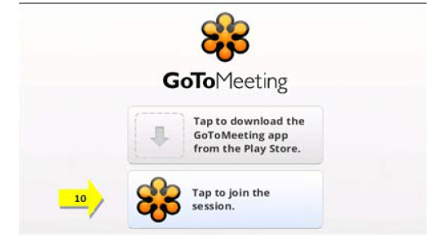

Once you have joined the webinar you will enter a ‘waiting room’ until the webinar organiser starts the webinar. Please make sure that your speakers are turned on to listen to the automated ‘welcome’ and then the webinar itself.

Once the webinar has started, you will see the presentation etc. from the organiser along with audio from the organiser; however, you will enter the webinar ‘muted’ so the organiser will not be able to hear you. Any questions you wish to ask during the webinar can be entered in to the chat function. This is shown below and the presenter of the webinar will talk you through this on the day. We will not be using the “raise hand” function.

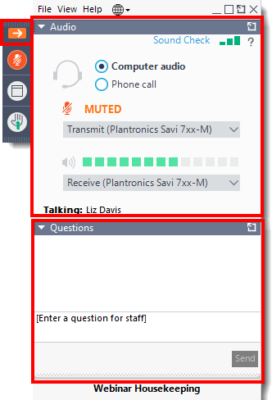

If at any time during registration or prior to the webinar you have any further queries please contact Kate Hudson at kate@hertsparentcarers.org.uk

